Project 1

**We have neither given nor received unauthorized assistance on this work**

**Name of VM:** Barak’s VM

**Instructor and root password:** derezzed

**Note:** the name of the instructor account is Barak Barclay

**Summary:** In task 0, we built the Linux kernel by downloading the kernel code, configuring it, compiling it, and installing it from the instructions given. In task 1, we added a new system call to print “Hello world!” and tested it using the instructions given. In task 2 & 3, we added two other system calls that would print out the PID, running state, and program name of a process and continued printing the same information until the init process. Task 2 used the current process while task used an arbitrary process.

**Code and explanation:**

System call for hello world:

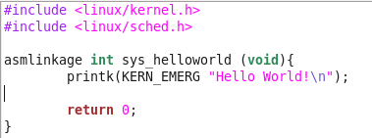

This system call was given in the instructions, but It was useful to learn how a system call works in a kernel.

System call for print self:

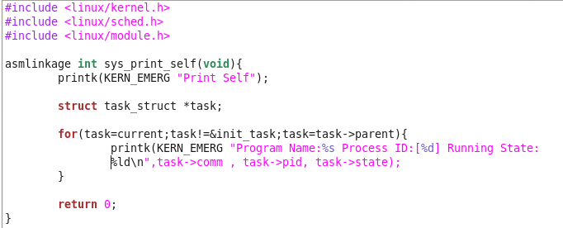

For this system call, the code from <https://linuxgazette.net/133/saha.html> given in the instructions was used and modified for this project. The name of the module was changed and the cleanup module was not used. We learned about how to get process information with task_struct here.

System call for print other:

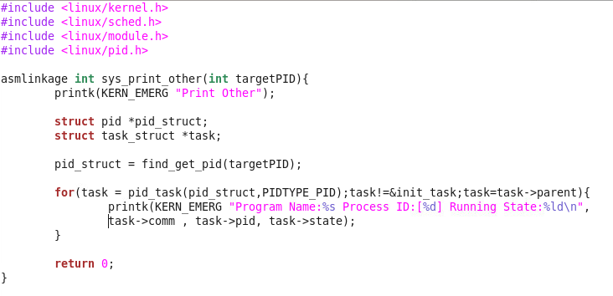

We looked up the function included in the pid header file and used it with the code we already used in the system call for print self. We also had to modify the module header to include a parameter.

System call test file:

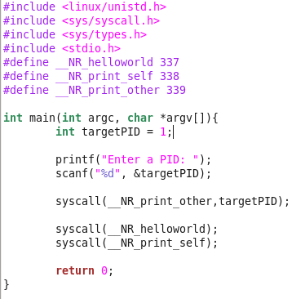

This was modified to include all three system calls and get a PID from the user to use in the print other system call. Since KERN_EMERG was used the order of the system calls was changed to work.

Make file:

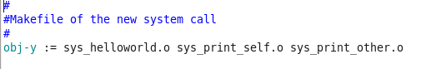

For the make file we added the additional object files like above, but we learned other ways to do it from the TA.

**Other Notes:** The changes to the other files are exactly the same as done in task 1, so they were not included in the report. Originally I thought I could do everything in root, so I had to change the permission on some of the files to get everything to work.

**Results:**

